UNIVERSITY OF THE EAST

Rating
152 Samson Road, Caloocan City
College of Engineering
Information Technology Department

CCS2102 – OBJECT ORIENTED PROGRAMMING
Laboratory Activity 6

Name | Gaspar, Ian Conner Earl B. | Section: | IT2G
Student Number | 20131129607 | Professor: | Celis, J. R. E.

INSTRUCTIONS:
- For each problem, paste the code and sample output here.
- Make sure your name and student number are printed at the end of the output.

EXAMPLE:

Sample Problem:

Create a program that accepts two numbers, then displays the sum, difference, product, and quotient.

Code: Sample Output:
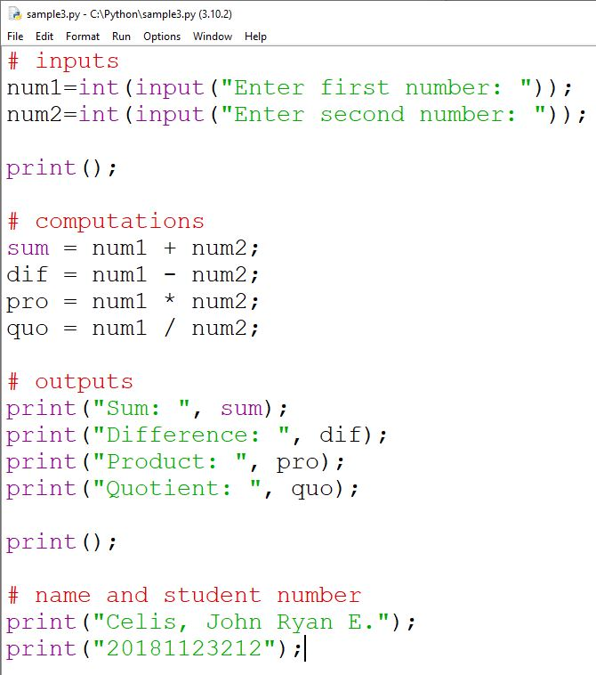
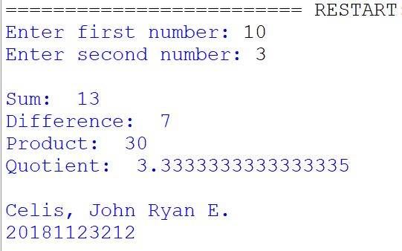

Problem:

- Complete the Employee class, Regular_Employee class, and Contractual_Employee class based on the lecture.
  - Create the Employee class
  - Create the Regular_Employee class
  - Create the Contractual_Employee class
- For the Contractual_Employee class’ computeSalary():
  - Make sure that the attribute Hourly Salary has a value.
  - Prompt the user to input the hours work.
  - Multiple the hours work to the hourly salary.
  - Display the result.
NOTE:
- Make sure that you write the program based on Classes, Objects, and Methods.
- Update your Journal to include this laboratory activity.

INPUT:

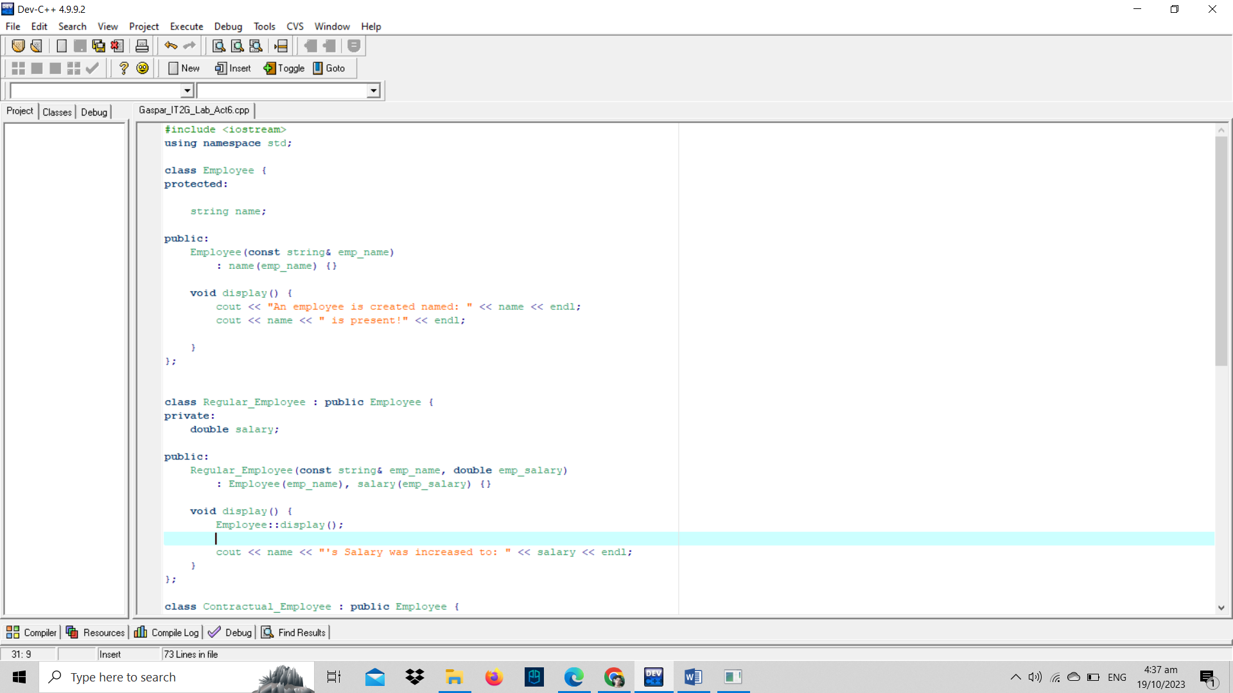
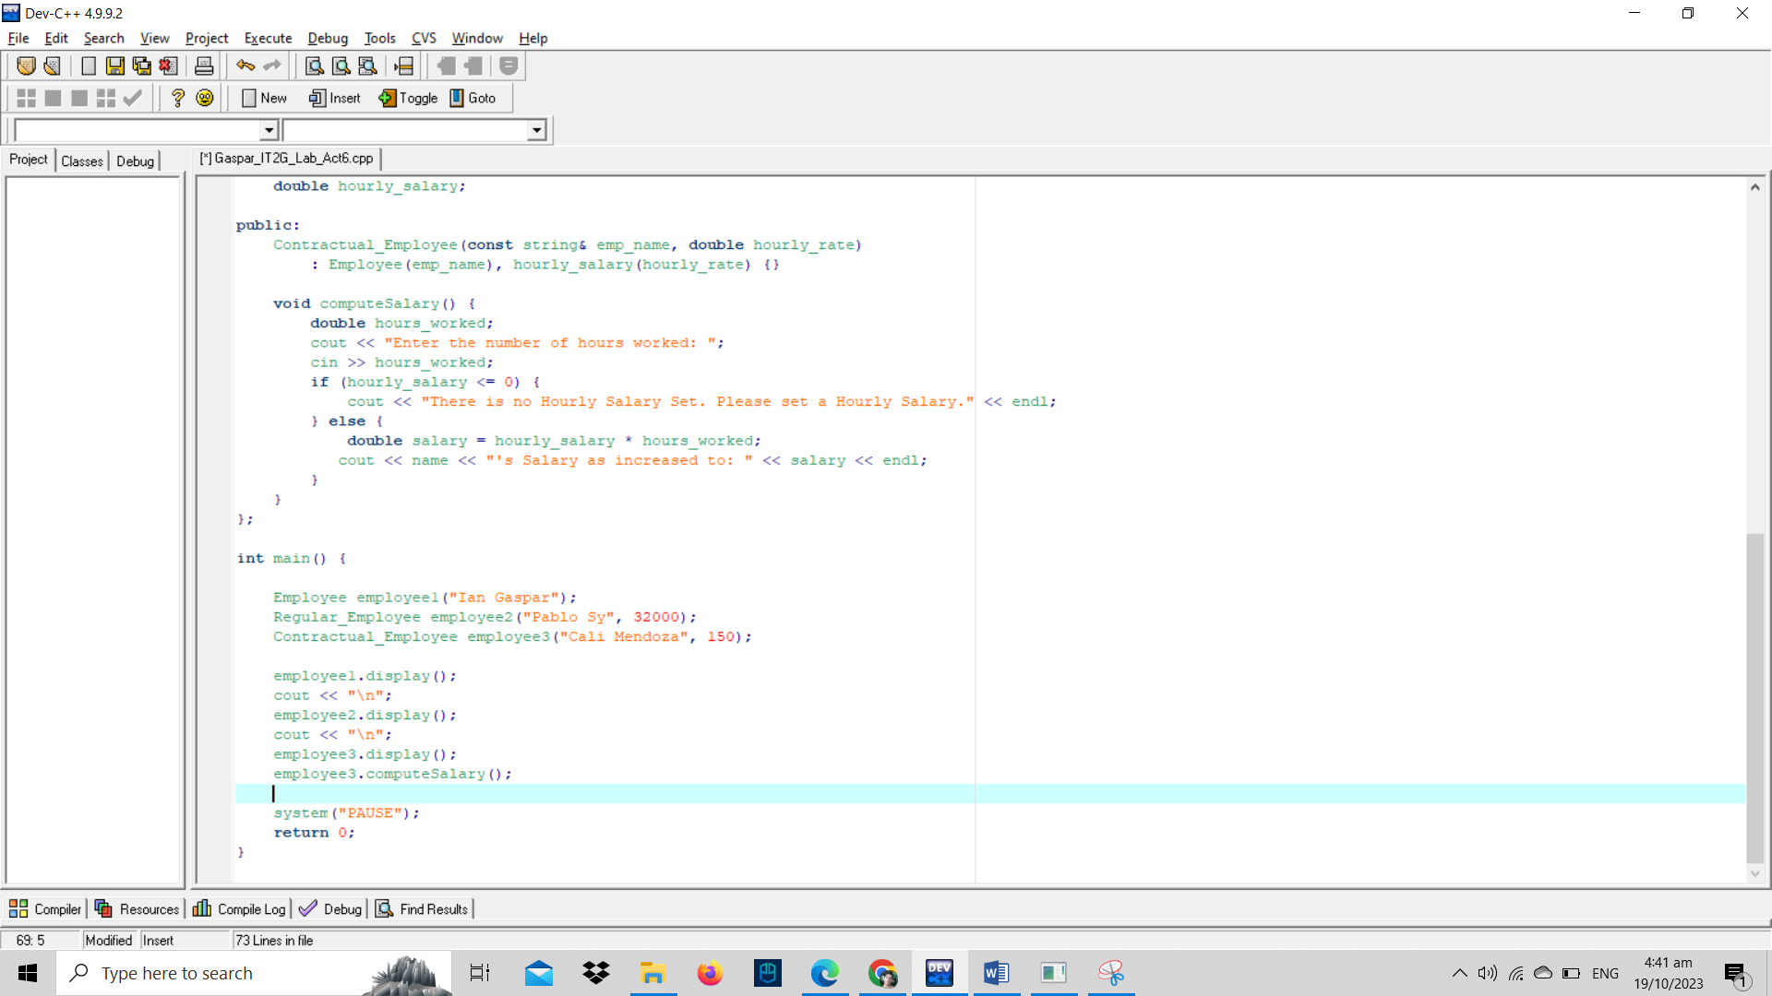

OUTPUT:
